1a)

PAC_theory_e=ARMAacf(ma=0,lag.max=20,pacf=TRUE)# white noise

PAC_theory_arma=ARMAacf(ma=0.6,ar=0.5,lag.max=20,pacf=TRUE)#arma(1,1)

e=rnorm(1000,0,1)

vk<-arima.sim(n=1000,list(order(1,0,1),ar=0.5,ma=0.6))

rho_o=acf(vk)

rho_f=1:30

A=matrix(data=NA,ncol=25,nrow=25)

for(i in 1:30)

{

rho_f[i]=rho_o$acf[i+1]

}

phi_i <-function(t,j,rho_f)

{

p=t-1

#return(1)

if(p==j)

{

if(p==1)

{

return(1)

}

else

{

sum=0

for(j in 1:p)

{

q=p

sum=sum+phi_i[q,j,rho_f]*rho_f[p+1-j]

}

numer=rho_f[p+1]-sum

sum1=0

for(j in 1:p)

{

q=p

sum1=sum1+phi_i[q,j,rho_f]*rho_f[j]

}

denom=1-sum1

final=numer/denom

return(final)

}

}

else

{k=p-j+1

q=p

t=p+1

s=phi_i[q,j,rho_f]-phi_i[t,t,rho_f]*phi_i[q,k,rho_f]

return(s)

}

}

for (p in 1:25)

{

for (j in 1:p+1)

{

A[1,1]=1

t=p+1

A[t,j]=phi_i(t,j,rho_f)

}

}

pac=1:25

for (i in 1:25)

{

pac[i]=A[i,i]

}

1c)

load('C:/Users/Toshiba/Desktop/vishal iit/5th sem/Applied time series analysis/assignments/assignment 3/a3_q1.Rdata')

plot(xk)

acf(xk)

pacf(xk)

t=arima(xk,order=(c(1,0,0)))# AR(1)

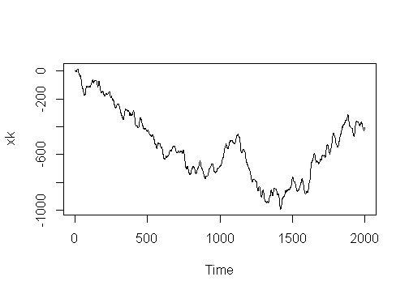

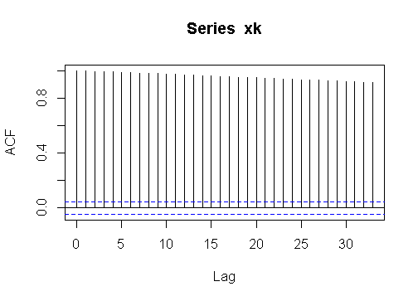

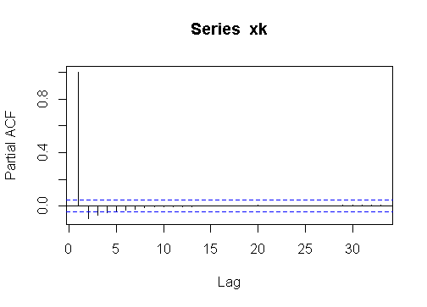

2)

load('C:/Users/Toshiba/Desktop/vishal iit/5th sem/Applied time series analysis/assignments/assignment 3/a3_q2.Rdata')

#a

t=1:1000

tr_fit<-lm(xk~t)

b=tr_fit$coefficients

plot(tr_fit$residuals,type='l',xlab='time',ylab='residuals of given data')

s_a=acf(tr_fit$residuals)

plot(s_a,type='h',xlab='lag',ylab='acf of residuals')

arma_a<-arma(tr_fit$residuals,order=(c(0,3)))

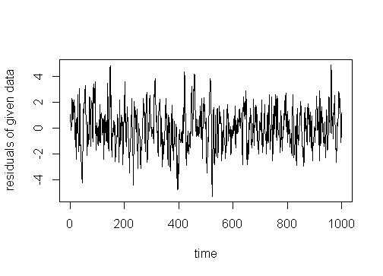

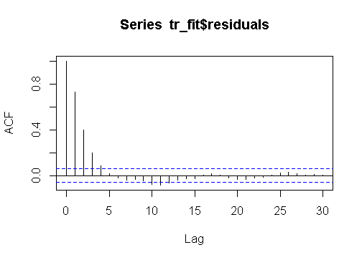

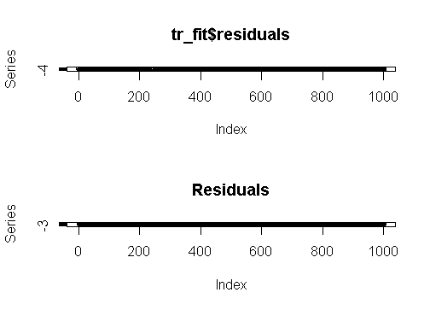

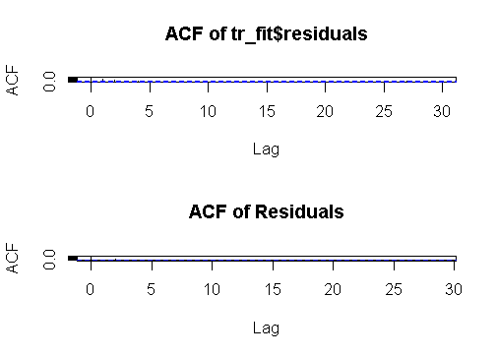

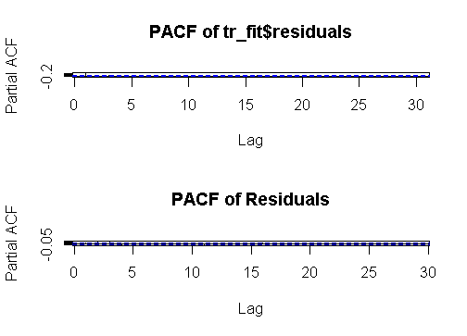

#b

plot(diff(xk),type='l',xlab='time',ylab='differences of given data')

s_b=acf(diff(xk))

plot(s_b,type='h',xlab='lag',ylab='acf of differences of given data')

s_b=arma_b<-arma(diff(xk),order=(c(0,3)))

plot(arma_a)

plot(arma_b)

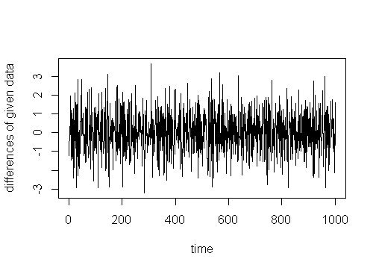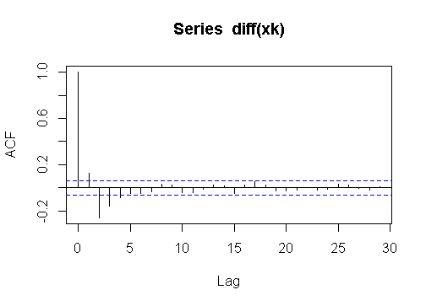

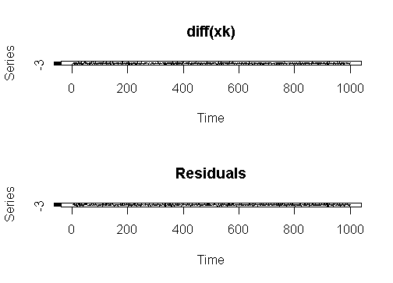

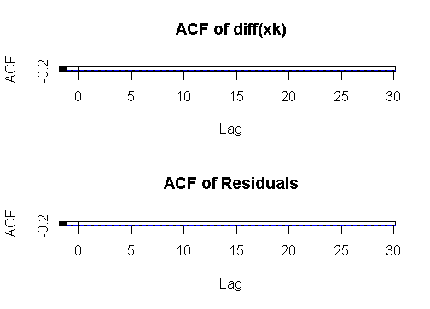

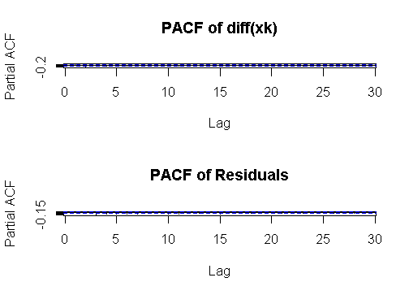

3a)

k=0:1000

xk1<-4*sin((pi*(k-2))/3.0)

t1<-fft(xk1)

plot(t1,type="h",xlab="K",ylab="DFT of 3a(1)")

mag1=abs(t1)

arg1=Arg(t1)

plot(arg1,type="h",xlab="K",ylab="phase spectra of 3a(1)")

plot(mag1,tpye="h",xlab="K",ylab="magnitude of 3a(1)")

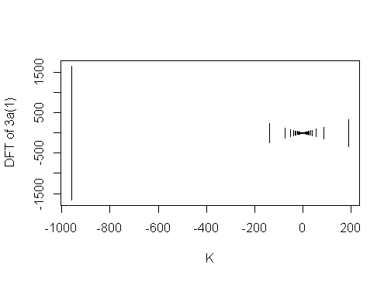

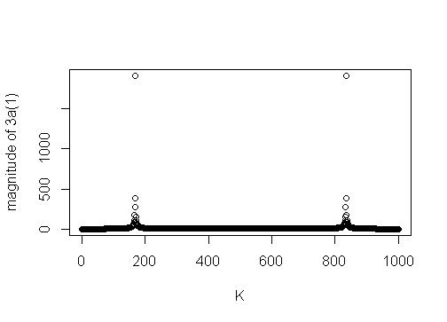

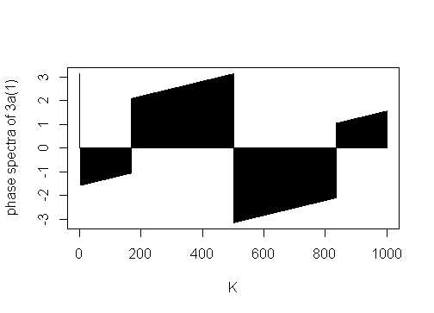

xk2<-cos((2*pi*k)/3.0)+sin((2*pi*k)/5.0)

t2<-fft(xk2)

plot(t2,type="h",xlab="K",ylab="DFT of 3a(2)")

mag2=abs(t2)

arg2=Arg(t2)

plot(arg2,type="h",xlab="K",ylab="phase spectra of 3a(2)")

plot(mag2,tpye="h",,xlab="K",ylab="magnitude of of 3a(2)")

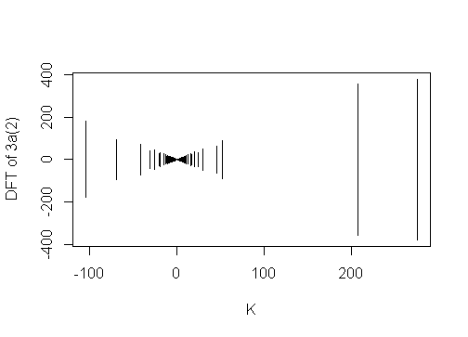

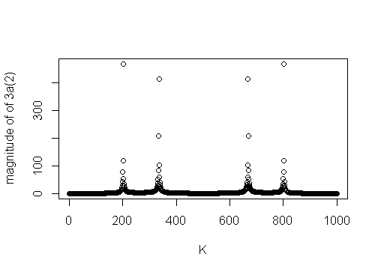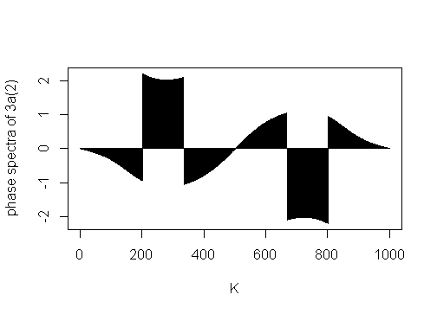

xk3<-cos((2*pi*k)/3.0)*sin((2*pi*k)/5.0)

t3<-fft(xk3)

plot(t3,type="h",xlab="K",ylab="DFT of 3a(3)")

mag3=abs(t3)

arg3=Arg(t3)

plot(arg3,type="h",xlab="K",ylab="phase spectra of 3a(3)")

plot(mag3,tpye="h",xlab="K",ylab="magnitude spectra of 3a(3)")

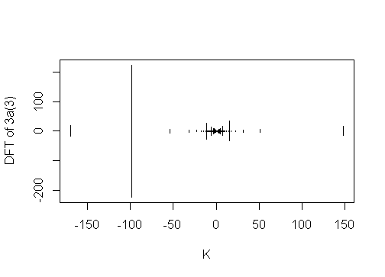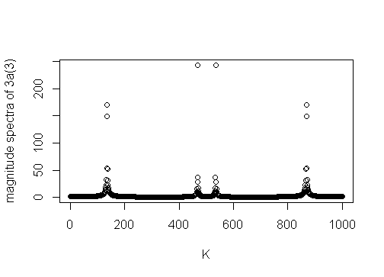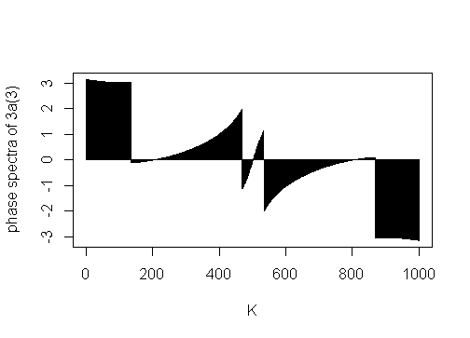

3c)

xk=c(1,0,1,2,3,2)#N=6

N=6

tk=fft(xk)

sum1=sum(xk*xk)#19

sum2=(sum(abs(tk)*abs(tk)))/N#114/6=19

#sum1 is equal to sum2 Hence we verified Parseval's theorem